HR Analytics Dashboard Report

1.Project Overview
The HR Analytics Dashboard is designed to analyze employee attrition, workforce demographics, job satisfaction, and education trends within an organization. The objective of this project is to identify the major factors contributing to employee attrition and provide actionable insights that can support HR decision-making and employee retention strategies.This dashboard was built using Power BI with data transformation performed in Power Query.

2. Dashboard Overview
The dashboard provides an interactive overview of employee information through KPIs, charts, and slicers.
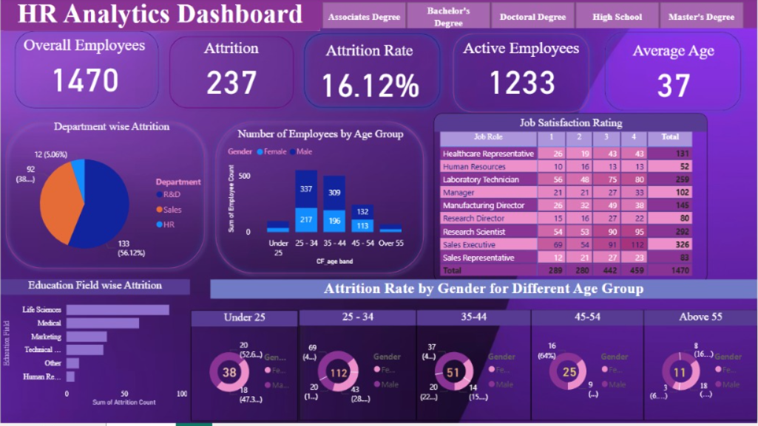

Key Performance Indicators (KPIs)
KPI | Value
Total Employees | 1,470
Employees Left (Attrition) | 237
Attrition Rate | 16.12%
Active Employees | 1,233
Average Employee Age | 37 Years
These KPIs provide an instant overview of workforce size and organizational health.

3. Dashboard Components

i. Department-wise Attrition
Visualization: Pie Chart
This visual displays employee attrition across different departments.

Insights
- Research & Development has the highest attrition.
- Sales follow as the second highest contributor.
- Human Resources have the lowest employee attrition.
Business Insight
HR should investigate workload, employee engagement, and career growth opportunities within the R&D department.

ii. Number of Employees by Age Group
Visualization: Clustered Column Chart
Employees are segmented into five age groups:
- Under 25
- 25–34
- 35–44
- 45–54
- Above 55

Insights
- Employees aged 25–34 represent the largest portion of the workforce.
- The workforce gradually decreases after age 45.
- Very few employees belong to the Above 55 category.
Business Insight
The company mainly consists of young and mid-career professionals.

iii. Top Satisfaction Rating by Job Role
Visualization: Matrix Table
The matrix compares employee satisfaction ratings (1–4) across various job roles.

Insights
- Laboratory Technicians and Sales Executives represent the largest employee groups.
- Satisfaction scores vary significantly across different job roles.
- Some managerial positions have relatively fewer employees but maintain balanced satisfaction ratings.
Business Insight
HR can identify departments where satisfaction is comparatively lower and implement targeted engagement initiatives.

iv. Education Field-wise Attrition
Visualization: Horizontal Bar Chart
Displays attrition based on employees' educational background.

Insights
Highest attrition is observed among employees from:
- Life Sciences
- Medical
- Marketing
Lower attrition is found in:
- Human Resources
- Technical Degrees
- Other Education Fields
Business Insight
The organization may need stronger retention strategies for employees from Life Sciences and Medical backgrounds.

v. Attrition Rate by Gender Across Age Groups
Visualization: Donut Charts
This section compares male and female attrition across different age groups.

Age Groups
- Under 25
- 25–34
- 35–44
- 45–54
- Above 55

Insights
- Employees aged 25–34 experience the highest attrition.
- Attrition gradually decreases with increasing age.
- Male employees contribute slightly more to attrition in most age groups.

Business Insight
Young professionals may require stronger onboarding programs, career development opportunities, and mentorship to improve retention.

4.Dashboard Filters (Slicers)
Users can interactively filter the dashboard using:
- Education Degree
  - Associate Degree
  - Bachelor's Degree
  - Master's Degree
  - Doctoral Degree
  - High School
Additional filters automatically update every visualization, allowing detailed workforce analysis.

5.Key Findings

Workforce Overview
- Total employees: 1,470
- Active employees: 1,233
- Average employee age: 37 years

Attrition Analysis
- Overall attrition rate is 16.12%.
- R&D department contributes the highest employee attrition.
- Employees aged 25–34 are the most likely to leave.
- Life Sciences employees show the highest attrition among education fields.

6.Employee Demographics
- Majority of employees belong to the 25–34 age group.
- Workforce composition gradually decreases with age.

7.Employee Satisfaction
- Satisfaction levels differ across job roles.
- Sales Executives and Laboratory Technicians form a significant portion of the workforce.

Business Recommendations

i. Improve Retention for Young Employees
Develop structured career progression plans, mentoring programs, and continuous learning opportunities for employees aged 25–34.

ii. Focus on High Attrition Departments
Conduct employee engagement surveys within Research & Development and Sales to understand the primary reasons behind employee turnover.

iii. Enhance Employee Satisfaction
Regularly monitor satisfaction scores and introduce recognition programs, performance feedback, and leadership development initiatives.

iv. Strengthen Career Development
Provide certification programs, internal promotions, and skill enhancement initiatives to increase employee loyalty.

v. Data-Driven HR Decisions
Use dashboard insights regularly to monitor workforce trends, evaluate retention initiatives, and support strategic HR planning.

8.Tools Used
- Power BI Desktop – Dashboard Development
- Power Query – Data Cleaning & Transformation
- Microsoft Excel – Dataset Preparation
- DAX – Calculated Measures & KPIs

9.Conclusion
The HR Analytics Dashboard provides a comprehensive view of employee demographics, attrition trends, job satisfaction, and workforce distribution. By transforming raw HR data into interactive visualizations, the dashboard enables HR professionals and business leaders to make informed decisions regarding employee retention, engagement, and workforce planning. The insights reveal that younger employees and the Research & Development department experience higher attrition, highlighting areas where targeted HR interventions can improve organizational stability and long-term employee retention.

